**Meghalaya**

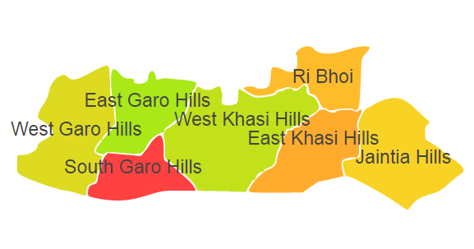

Meghalaya comprises of one Agro Ecological Region (AER) 17.

**Agro-Eco Region 17:** AER 17 in Meghalaya comprises of East Garo Hills, East Khasi Hills, Jaintia Hills, West Khasi Hills, Ri Bhoi and South Garo Hills districts of North-eastern Hills under Agro Ecological Sub Region (AESR) 17.1.